Steamboat
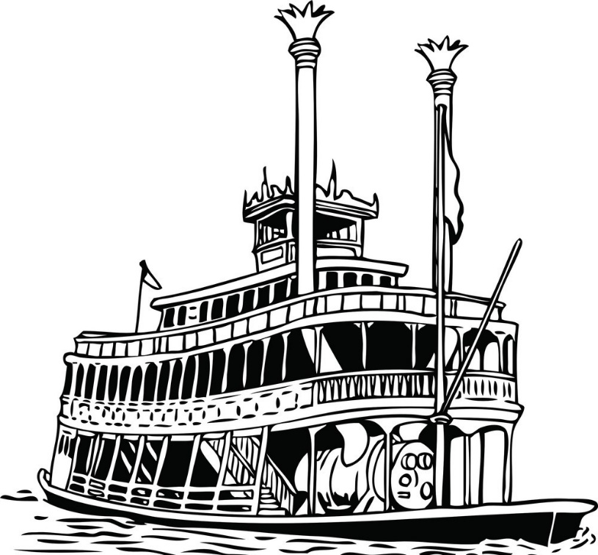
In 1807 inventor Robert Fulton launched his first steamboat, the Clermont, on the Hudson River. Steamboats made fast upstream travel possible and carried goods and people more cheaply and quickly along rivers than sailboats could. By 1860, about 3,000 steamboats traveled the country’s large rivers and canals, as well as the Great lakes. This encouraged the growth of cities like Cincinnati, Buffalo, and Chicago.

Steel-tipped plow

No trees and hard, packed in soil meant that many farmers would not risk moving out to the Great Plains if they could not grow enough food to survive. Even areas of mixed forest and prairie seemed too difficult for farming. They also worried that the soil would not be fertile enough to support fields of crops.
Inventions like the steel-tipped plow helped ease farmers’ worries. Developed by John Deere in 1837, they allowed farmers to cut through the hard packed prairie sod. Knowing that they would be able to farm the land on the prairies helped people make the decision to move west.
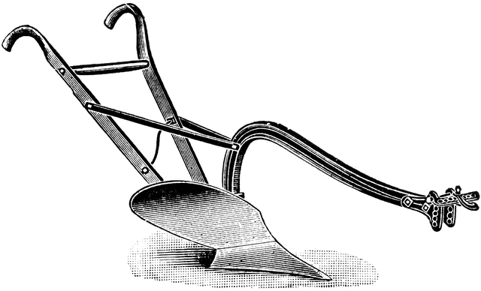

Steam Locomotive (Train)

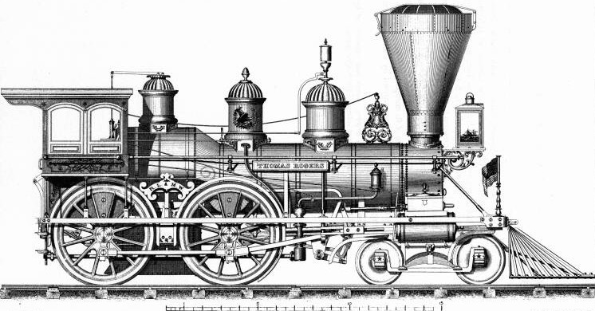
Trains are starting to appear and quickly revolutionize transportation. Goods and people can now be moved very quickly, instead of being pulled along by horse and cart. Over thirty thousand miles of railroad track began popping up all over the country but most of the track is concentrated in the Northern states. These new trains got a rough start trying to perfect steam power (the original steam train made by Peter Cooper in 1830 lost a race to a horse drawn train—yes, they were a thing— after its engine failed.)

The Telegraph

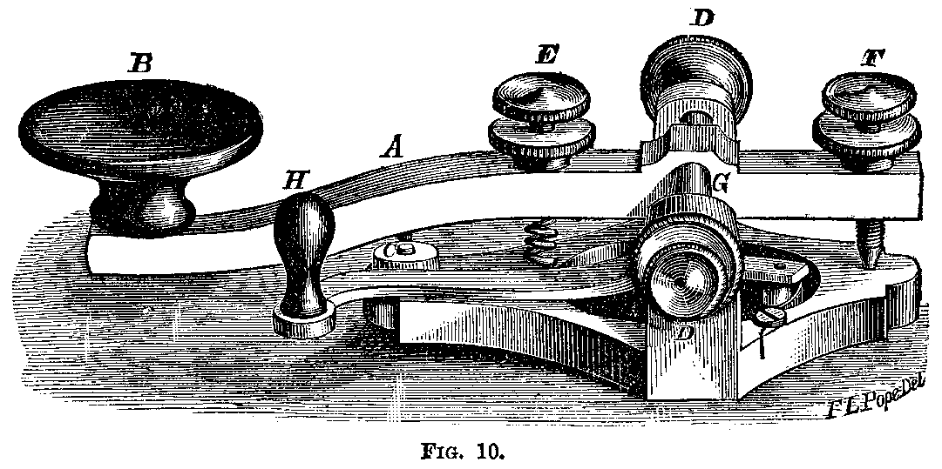
The growth of industry and the new pace of travel created a need for faster methods of communication. The telegraph—a device that used electric signals to send messages—filled that need. Samuel Morse created a system for sending coded messages instantly along electrical wires.
Telegraph operators sent messages quickly by using Morse Code. This code used different arrangements of short and long signals, dots and dashes, to represent letters of the alphabet and was finally perfected in 1844. By 1852 there were 23,000 miles of telegraph wires hanging in the United States. People could get information in minutes instead of days. News would spread pretty quickly in this new era of instant communication!
Sewing machine
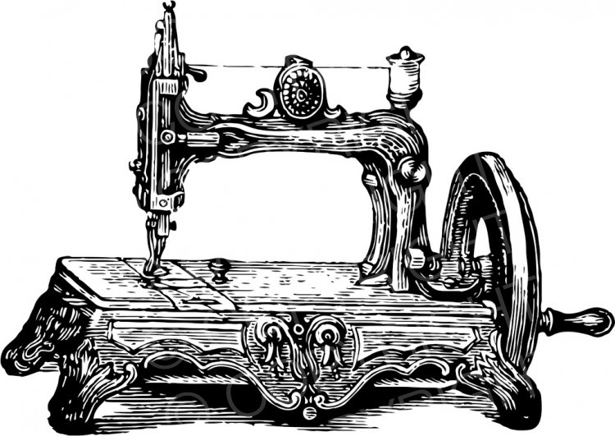
In the olden days all clothes had to be made by hand. A woman might spin the thread, weave the cloth, then cut and sew the fabric. Once large machines called looms wove cloth using the power of flowing water a worker could simply sew the whole piece of clothing together using a sewing machine. Invented by Elias Howe in 1846, these early machines either worked through a hand crank or foot peddle and did not run on electricity (that would come much later).

New sailing technologies

Sailing technology also improved in the 1840s. The new clipper ships featured tall sails and sleek hulls. They could sail 300 miles (483 km) per day, as fast as most steamships at that time. Clipper ships got their name because they "clipped" time from long journeys.

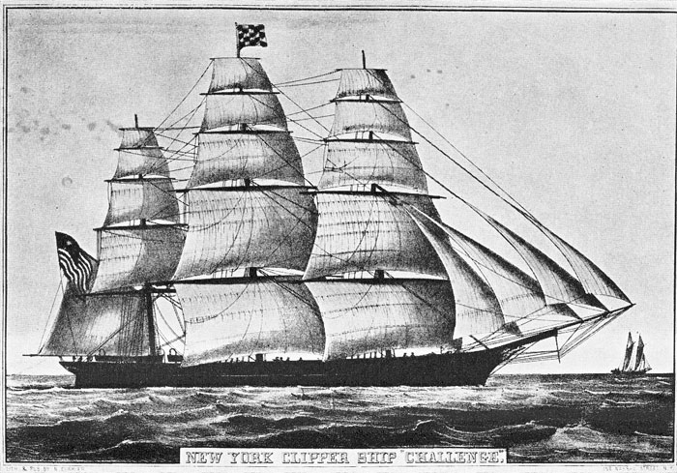

Before the clippers, the voyage from New York to Great Britain took about 21 to 28 days. A clipper ship could usually cut that time in half.

Mechanical Reaper
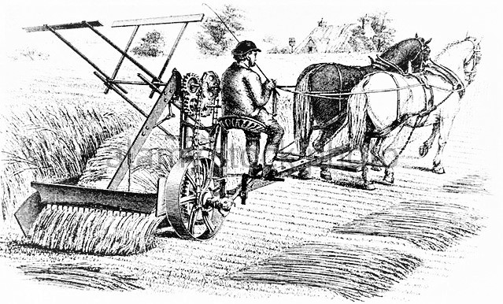
Cyrus McCormick was the genius behind the invention of the mechanical reaper. Before this invention, farmers had harvested grain with handheld cutting tools. McCormick's reaper went on sale in 1834.
It increased the amount of crop a farmer could harvest. Because farmers could harvest more wheat, they could plant more of it. Growing wheat became profitable (made money). Raising wheat became and would stay the main money-making activity on the Midwestern prairies.

