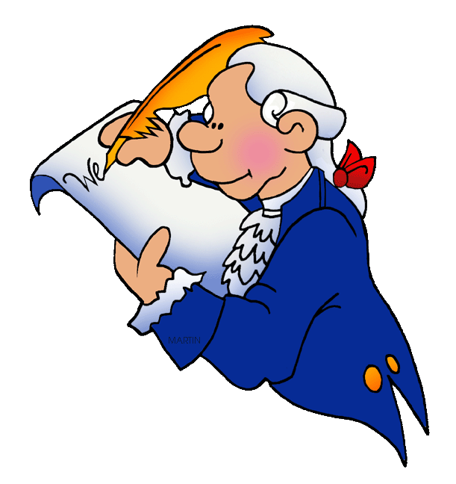
2018 First Quarter Civics Standards:

SS.7.C.1.1: Recognize how Enlightenment ideas including Montesquieu’s view of separation of power of John Locke’s theories related to natural law and how Locke’s social contract influenced the Founding Fathers.
Words to know: | Explanation
Enlightenment –  Montesquieu  Locke  (SS.7.C.1.1) | Enlightenment-period of time when people started questioning the government  Montesquieu – divided government into parts (separation of powers) with each part equal or balanced with the other parts (branches) (checks and balances)  Locke-Humans are born with basic rights to life, liberty, property, and the freedom fo find happiness, social contract is when people give power/rights to government in exchange for protection.
SS.7.C.1.2: Trace the impact that the Magna Carta, English Bill of Rights, Mayflower Compact, and Thomas Paine’s “Common Sense” had on colonists’ views of government.
Words to know: | Explanation
Magna Carta
(SS.7.C.1.2)
English Bill of Rights
(SS.7.C.1.2)
Mayflower Compact
(SS.7.C.1.2)
Thomas Paine’s
Common Sense
(SS.7.C.1.2)

SS.7.C.1.3: Describe how English policies and responses to colonial concerns led to the writing of the Declaration of Independence.
Words to know: | Explanation
Events leading to the Declaration of Independence
(SS.7.C.1.3)
S.7.C.1.4: Analyze the ideas (natural rights, role of the government) and complaints set forth in the Declaration of Independence.
Words to know: | Explanation
Natural Rights and the role of government
(SS.7.C.1.4)
SS.7.C.1.5: Identify how the weaknesses of the Article of Confederation led to the writing of the Constitution.
Words to know: | Explanation
Weaknesses of the Articles of Confederation
(SS.7.C.1.5)
SS.7.1.6 Interpret the Intentions of the Preamble of the Constitution.
Words to know: | Explanation
Preamble

We the People

In order to form a more perfect union

Establish justice

Ensure domestic tranquility

Provide for the common defence

Promote the general welfare

Secure the blessings of liberty to ourselves and our posterity

Do ordain and establish

SS.7.C.1.7: Describe how the Constitution limits the powers of government through separation of powers and checks and balances.
Words to know: | Explanation
Power limits –
Separation of power
(SS.7.C.1.7)
Power limits –
Checks and balances
(SS.7.C.1.7)
SS.7.C.1.8: Explain the viewpoints of the Federalists and the Anti-Federalists regarding the ratification of the Constitution and inclusion of a bill of rights.
Words to know: | Explanation
Views of Federalists
(SS.7.C.1.8)
Views of Antifederalists
(SS.7.C.1.8)
Ratify
SS.7.C.1.9: Define the rule of law and recognize its influence on the American legal, political, and governmental system.
Words to know: | Explanation
Rule of Law – how it influences the development of our government
(SS.7.C.1.9)

SS.7.C.2.1 Define the term “citizen”, and identify legal means of becoming a U.S. citizen. (Introductory week of school)
Words to know: | Explanation
Citizen

SS.7.C.3.1: Compare different forms of government (direct democracy, representative democracy, socialism, communism, monarchy, oligarchy, autocracy).
Words to know: | Explanation
Direct democracy
(SS.7.C.3.1)

Representative democracy
(SS.7.C.3.1)
Socialism
(SS.7.C.3.1)
Communism
(SS.7.C.3.1)

Monarchy
(SS.7.C.3.1)

Oligarchy
(SS.7.C.3.1)

Autocracy
(SS.7.C.3.1)

SS.7.C.3.2: Compare parliamentary, federal, confederal, and unitary systems of government.
Words to know: | Explanation
Parliamentary government
(SS.7.C.3.2)
Federal government
(SS.7.C.3.2)
Confederal government
(SS.7.C.3.2)
Unitary government
(SS.7.C.3.2)
SS.7.C.3.3: Illustrate function (three branches of government in Articles I, II, and III with corresponding powers) of government in the United States as established in the Constitution.
Words to know: | Explanation
Legislative Branch

Executive Branch

Judicial Branch

